**The Bad Book Club**  
  
"It was a terrible film, and I really enjoyed it" - Alan Riach on *Rob Roy*.

|  |  |
| --- | --- |
|  |  |
|  |

|  |
| --- |
| The Bad Book Club got going on Sunday (20 October 2024) when there was nothing left in the fridge and everyone agreed to forego an evening at the village café or music on the piano in order to be told why not to read an ancient best-seller they might never have broached in the first place.  There was Rae Riach, who had run a real book club for 20 years and participated in others; Mariarosaria Cardines, who has a tough spot for fashionable tomes; Chris Larsen, our host, who prefers to play Bach or to cook; Cesar R, our other host, who laughed and kept things in order; Alan Riach, who had just become *two* professors, and PMcC, who couldn't just let people get on with what they were doing. Plus Alba, the affable hound.  The BBC does have rules; I made them up. Here they are:  1. For successful but awful books or films or recordings, the idea is to spare other readers the annoyance of putting up with them (the books, not the readers). Plot spoilers welcome. 2. For unjustly neglected items, the aim is to persuade the others that they are worth broaching. Whether this means giving readers a text in advance is up to you. 3. It's easier to demolish a monument than to resuscitate a flop, so let's have more of the latter. 4. Each reader should come prepared to present a book or film, in case there's time for more than one in a session. 5. No living authors are to be picked apart; not in the minutes, at any rate. Unless they are extremely famous and even more annoying. 6. Each meeting should be mostly real, and people should travel to it as best they can. 7. The consumption of food and drink at such meetings is not excluded. 8. Meetings to be convened ad hoc by whoever can be bothered. 9. Membership by invitation, coopting or court order. 10. Any other rules.    Cesar Rodriguez Castello, Mariarosaria Cardines, Chris Larsen, Peter McCarey, Alan Riach, Rae Riach  Here is the Bad Book Club at the Ducal Palace of the Borgia family, in Gandia. The audioguide talks up the Borgia popes and the Jesuit Borgia saint, but doesn’t mention Lucrezia, or Cesare, Machiavelli’s poster boy. The bakery next to the palace sells the best empanadas on the planet.  Rae had a couple of famous boring authors in her sights (I don't yet know which ones). Also, prior to the real meeting, some of us did discuss the club by email, as follows:    30 Sep 2024, PMcC: Hah, You all thought you'd planned a holiday, but it's more than that! It's also the Bad Book Club. I'd like to kick off by disrecommending Rousseau's *La Nouvelle Héloïse*, which I guess you had no intention of reading anyway; it was the Harry Potter of its day. I'll be talking up two related works. And I hope you've got your proposals ready.  AR:  Immediate suggestions: The first sentence of the first of the Harry Potter books. That’s far enough in that direction. (Surely Jakey does not qualify as a living author?) Any poem by W.H. Auden. (Some of his essays do not qualify as bad enough. None of the poems suggest any reason to read any more of them.) Bad books I have enjoyed include: Louis L’Amour, Galloway (but only because of the title); Shalako (which does in fact have a great first sentence); The Sky-liners (I can’t remember anything about it except the cover painting); and Matagorda (which has a description of a flood in the town of Matagorda, in Louisiana, near New Orleans, which is exemplary in being bad writing about a tremendous occurrence); but almost any of L’Amour’s books would qualify, I suppose. Tarzan, of course. But where to start? There are two classic pairings, The Beasts of Tarzan and The Son of Tarzan (with the villains Rokoff and Paulvitch), and Tarzan the Untamed and Tarzan the Terrible (he eats a vulture in the first one and tames a triceratops in the second one), but I suppose the most appropriate standalone novel would be Tarzan and the Jewels of Opar. The Parker books. Are they good bad books or bad good books? They do contain some truly great sentences, including the best single sentence ever written by anyone anywhere, ever. (That’s an ‘ever’ twiced!) And sometimes they have individual words that are really brilliant. (Not only in themselves but in where they are placed.) I find it difficult to choose one. You probably need to read all 24 of them to get a sense of the trajectory. Or 28 if you include the Grofield books, which overlap the Parker series. And if you really want, the Dortmunder series as well, since the first one ends with a character named Green telling someone that his real name is Grofield. (Though you’d be a fool to believe him, of course.) There are others. Conundra: ‘Good’ by what rule? ‘Bad’ by what definition? But I guess those are the kind of questions that stink up the joint, as Duke Ellington said when he was asked if he was influenced by Debussy. That’s probably enough from me to begin with. Alan  3 Oct 2024, CL:  Hello everyone.  Words like "prepare" and "present" or even "text" remind me in a slightly worrying way of the word "task", and I have reminded myself that having happily given up a wide range of tasks on retirement, I thought I could then just devote myself to those that remained, such as anything to do with cooking, a bit of piano, not going into the village without trousers on and remembering to continue breathing at all times where posssible.  I'm sure there are others.  But going on about it this way now also makes me want to say, well, "making up the rules as you go along" is there in the instructions as clear as daylight, so what's to worry about?   I'm sure we'll all approach it, as and when, with good humour and a bottle of good wine at hand.  Looking forward lots to seeing you.  Chris  PMcC:  The Bad Book Club is meant for rainy days in company. And it might not rain, in which case - no worries.  Btw I came across this while looking for free copies of Alan's suggestions:  Macintosh HD:Users:petermccarey:Desktop:Screen shot 2024-10-27 at 11.23.43 PM.png |

As to Auden - there's one line I've always liked: "Where lights and wine are set for supper by the lake". Maybe that's 2 lines. Evokes a posh pre-war feast somewhere in Nazi Germany as though there were nothing sinister in the background. Goodness me! Why do I find that likeable?

Beware of mocking one of England's house gods though: PN Review never published me again after I fumigated Geoffrey Hill in an essay they commissioned. And didn't print.

See you soon!

Peter.

CL:

Would that have been the Wannsee Conference Peter?   But the line has a lovely melody of changing vowels.

Chris.

AR:

I met Geoffrey Hill within thirty seconds of meeting Pam Ayres, in Buckingham Palace, in 2013, in a crowd of around 350 people, in a very big room surrounded by Tintorettos, silver salvers, and equerries, at least one of whom, I was informed, was armed. He (Hill) scowled and chewed his cheeks. She beamed and flashed her teeth and fringe. Their eyes, I remember quite vividly: respectively, his, grim, and hers, optimistic. I could judge them on those things alone, but, no need.

More anon.

Alan

PS: The quality of ‘liking’. How is that line ‘likeable’? I see what you mean, I think, but does it equate with the accurate depiction of the repulsive? Changing vowels / moving bowels. Which may be admirable right up to becoming likeable, but I think it is suspect.

CL: I just wanted to say in response to Alan's point(s) about liking and likeable and the depiction of the repulsive, that the behind of the torturer's horse *WAS* innocent, in that deservedly famous and excellent poem by Auden.  Or wasn't it ?

**Musée des Beaux Arts (1940)**

About suffering they were never wrong,  
The [Old Masters](https://www.oed.com/view/Entry/258510#eid10971790): how well they understood  
Its human position; how it takes place  
While someone else is eating or opening a window or just  
walking dully along;  
How, when the aged are reverently, passionately waiting  
For the miraculous birth, there always must be  
Children who did not specially want it to happen, skating  
On a pond at the edge of the wood:  
They never forgot  
That even the dreadful [martyrdom](https://www.oed.com/view/Entry/114477) must run its course  
Anyhow in a corner, some untidy spot  
Where the dogs go on with their doggy  
life and the torturer's horse  
Scratches its innocent behind on a tree.  
  
In Breughel's Icarus, for instance: how everything turns away  
Quite leisurely from the disaster; the ploughman may  
Have heard the splash, the forsaken cry,  
But for him it was not an important failure; the sun shone  
As it had to on the white legs disappearing into the green  
Water; and the expensive delicate ship that must have seen  
Something amazing, a boy falling out of the sky,  
had somewhere to get to and sailed calmly on.

PMcC:

**The Connoisseur**

‘About suffering they were never wrong,

The Old Masters’ – Auden had seen them all

And he knew all there was to know

About suffering. That’s what he says.

He’s not for Antonello, Van der Weyden

Or any icon focused utterly

On what, if anything, pain might mean.

Here, doggy. Good boy.

Alan Riach

**After the Torturer’s Horse**

Well, that was then. Old Daedalus had made the wings.

They worked. The boy flew. But he wanted to fly higher.

Grow! He said. Grow the economy! Higher!

But he spread the wax till all the passing people

Got stuck in its stickiness. There were the fools, who said,

This is the way: we simply couldn’t do it for ourselves.

There were the cowards, who said, it scares me, best

Just do as we’re told. There were the bastards, who knew

What would come and feathered their own nests, regardless.

So now when the foolish child flies up too close to the sun,

Nobody carries on, unseeing or uncaring. Everyone’s

Caught up in the disaster. Anyone can see. And all old folk

Can do, is point it out, or else work in the vast denial industry,

The media. Folk do not go on as before. We follow the torturer’s horse.

Back to Alan: PPS, from his *She* collection:

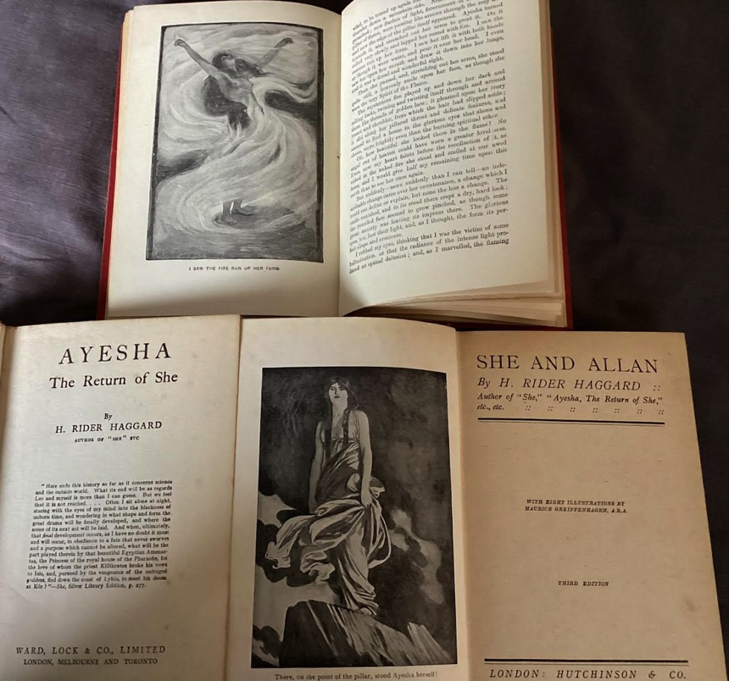

But then, as W. B. Yeats said on first entering a pub, ‘Higgins, I don't like it. Lead me out again.’ (See W.R. Rodgers, *Irish Literary Portraits*, pp. 4-5.)

Though perhaps you might like to add the attached, the 'consequence' of my early ramblings in darkest Africa, and my encounter with She Who Must Be Obeyed, the encounter of a solitary reader, emboldened only by the knowledge that my grandfather had been there long before. Ever since then, some part of me has always felt just like that poor man, precipitously dangling, swaying to and fro, dependent upon the grip and grasp and strength of his friend to hold on to him and help him back to the relative safety of that slanting pinnacle, lonely as it was, and in the middle of a vast mountain range in a far-extending desert.

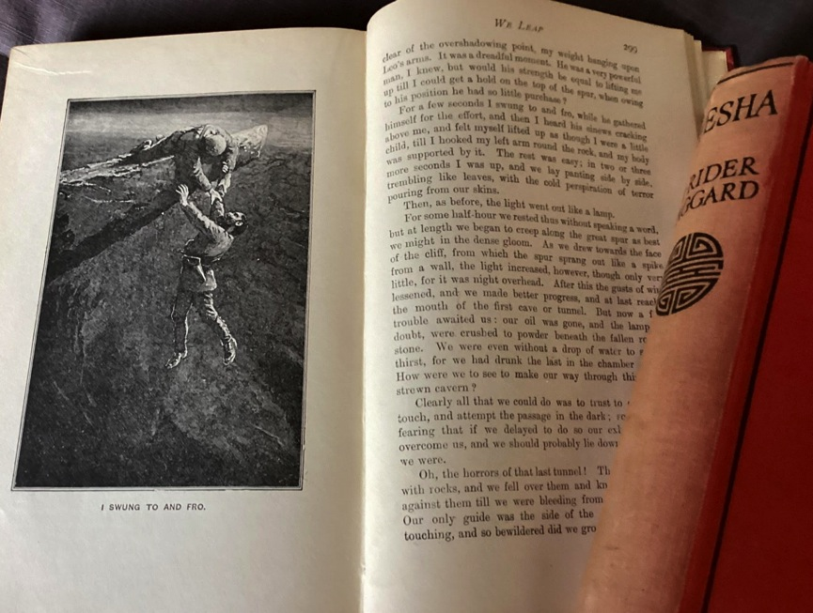

That's what friends are for, as Shere Khan says in *The Jungle Book*.

Anent quhilk, I have just started rereading *Tarzan of the Apes* and am enjoying it immensely.

Aye,  
Alan

So much for the email exchange.

The fun starts when people meet. On the day, James Boswell took the biscuit, in spite of stiff competition from Casanova and Rousseau, not to mention Voltaire. At one inn a lady had said to Casanova that gentlemen at dinner had to be prepared to deal with insulting behaviour from other guests:

… un homme d’honneur ne devait jamais se hasarder de s’asseoir à une table d’hôte s’il ne se sentait pas disposé à se battre, malgré toute la prudence possible. Cela était très vrai dans ce temps-là, car pour un mot de travers, il fallait mettre l’épée à la main, s’exposer aux fâcheuses conséquences d’un duel, ou se voir montrer au doigt, même par les dames.

‘Fâcheuses conséquences’, eh? At that first BBC I had decided to show the different ways in which Boswell and Casanova square up. So I quote an incident from each, to be relished in full. [1][2] Each was en route to interviews with Voltaire and Rousseau.

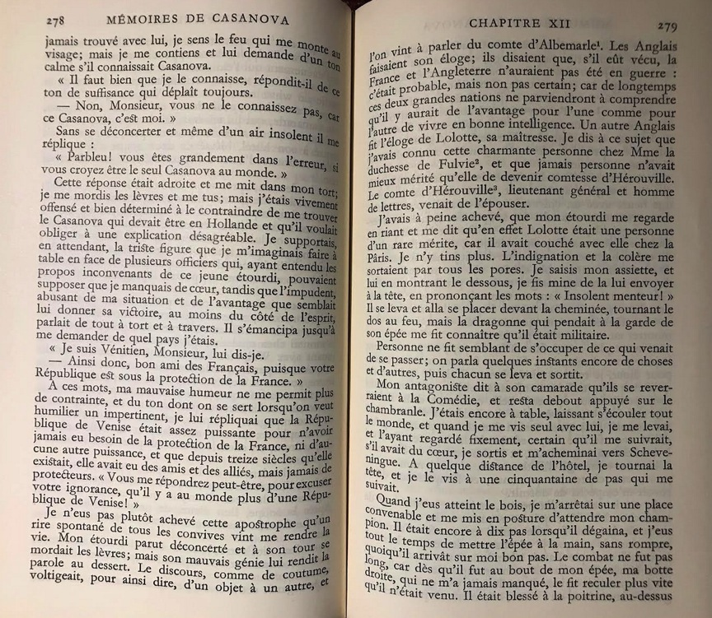

So Casanova is at table in an inn when a French dragoon mocks him: you’re not the only Casanova in the world. And Venice is under French protection. Never, says our man, the Republic of Venice has looked after itself for 1300 years – though perhaps you’ll tell me it’s not the only Venice! When the soldier claims to have slept with a countess our hero knows, Casanova calls him an insolent liar. The room quietly clears. The soldier pulls back his coat to reveal his weapon (cue Morricone!). C. leads the way, the soldier follows him, draws and lunges, but C. puts his trusty right boot forward and skewers the soldier. He’ll survive.

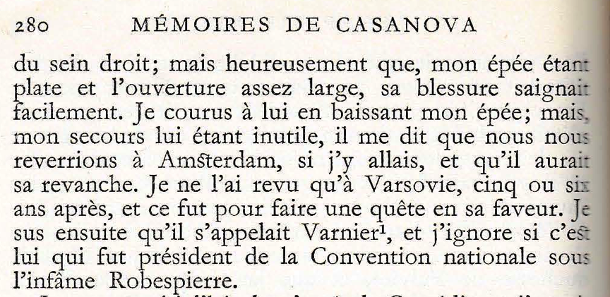

This will have been in The Hague, in September 1759.

Now for Boswell, in Berlin, five years later, also en route to Geneva, and another pesky French soldier:

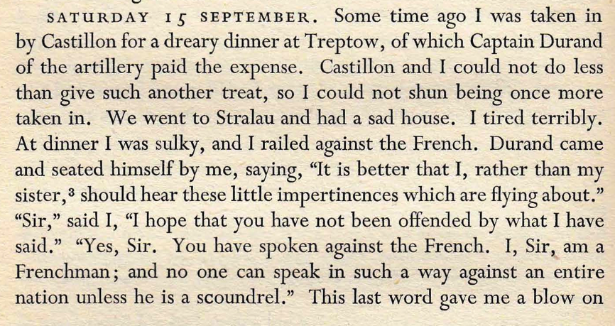

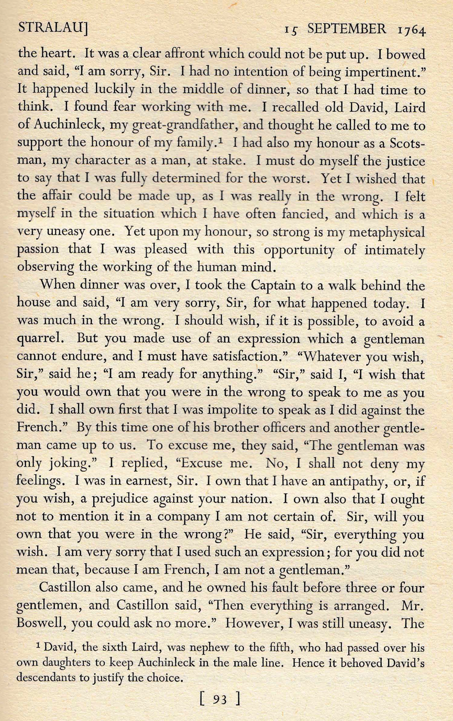

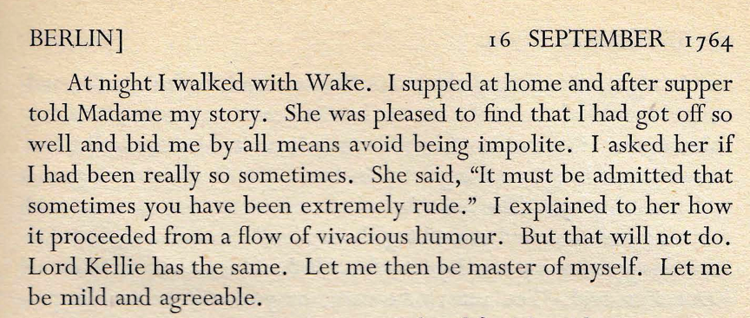

Now, a good friend of mine wasn't going to believe that Casanova had the courage and skill he laid claim to because, as a southern European, the Venetian would have been incapable of Boswell's embarrassing candour. I did point out that, though Casanova wasn’t always to be trusted, the details of this story, including the loser's name (checked and corrected by the editor, Robert Abirached) were pretty convincing. I would grant, though, that Casanova seldom puts himself in what he would regard as a poor light – a bit like his compatriot Curzio Malaparte, who always gives himself the winning quip in any conversation (now there's another candidate for the BBC: *La Pelle*, or *Kaput*). Then again there are incidents in Casanova's memoirs when he is bested and admits it. Never, though, with the toe-curling grotesque of the great Boswell, whose only rival I can see in that area is Dostoevsky.

Where is Rousseau in all this? We were all enjoying Bozzy so much that it seemed a shame to move on to a novel that I assured my friends was awfully dull.

To quote my own summary, *La Nouvelle Héloïse* is *Dangerous Liaisons* without the danger. And without the liaisons. For all its ostentatious chastity, there's something sadistic in the way the dominant couple manipulates the young hero, St Preux, into a platonic *ménage à trois*. The only bit of the book I warmed to was where St Preux is a guest of Swiss peasants in the high valleys of the Canton of Valais, towards the end of the book. But that's just me. Jean Starobinski loved it. Boswell read it excitedly as he approached Rousseau's home - though how he got his hands on the tome isn't explained: people were so desperate to read it that they would rent a copy overnight. Rousseau had to admit that St Preux was a self-portrait. Boswell never reciprocated by confessing his own later liaison with Rousseau's mistress Thérèse le Vasseur who, by the by, had shown no interest at all in Casanova, when he showed up. I see I'm digressing again: that's what Héloïse does to me. Twelve ‘reprehensible’ pages of Boswell’s account were destroyed by his literary executor, though as the Yale edition has it:

Next day he was very proud of himself, and in the coach he congratulated Thérèse (who was almost twenty years his senior) on her good fortune in having at last experienced the ardours of a Scotch lover. Thérèse stunned him by denying that she had great cause for gratitude: “I allow”, she said, “that you are a hardy and vigorous lover, but you have no art.” Then, with quick perception seeing him cast down, she went on, “I did not mean to hurt you. You are young, you can learn. I myself will give you your first lesson in the art of love.”  
Since Boswell’s success as a lover depended on his maintaining a feeling of superiority this announcement filled him with terror.[3]

What's so bad, then, about the Bad Book Club?

Above the door of Philip II's library in the Escorial this warning is engraved:

AY EXCOMUNIÒN DEL PAPA GREGORIO XIII RESERVADA A SU SANTIDAD PARA NO SACAR LIBROS NI OTRA COSA DE ESTA BIBLIOTECA. DADA EN ROMA, EN XV DE OCTUBRE DE MDLXXII.

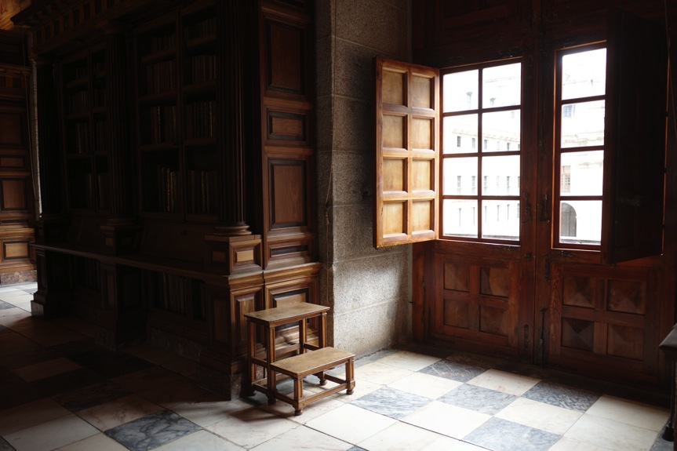

‘Automatic excommunication if you steal a book from this library (as of 15 October 1572)’ – a library which, incidentally, held a copy of the books that were confiscated and banned by the Inquisition; the index of forbidden books had been initiated in 1559. A canon of sorts – and a bad book club.

We have no idea where or when the next BBC meeting will be, though it has to be real and it would be unlikely to match the gentle hospitality and the general hilarity of the first one, as hosted by Chris and Cesar.

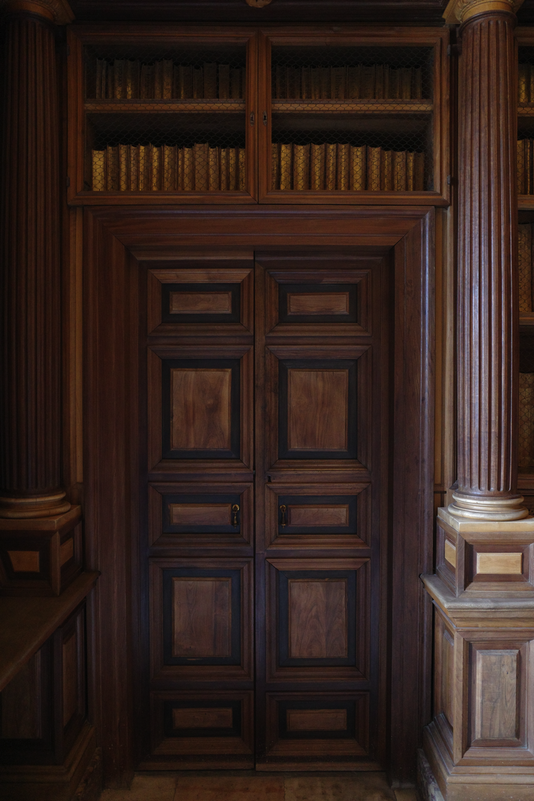

1. Casanova, *Mémoires* II (1756-1763) (Paris, Gallimard, 1959), pp. 278-280.
2. Frank Brady and Frederick A. Pottle (editors), *Boswell on The Grand Tour : Italy, Corsica and France 1765-1766* (London, Heinemann, 1955), pp. 92-95.
3. Frank Brady and Frederick A. Pottle (editors), *Boswell on The Grand Tour : Italy, Corsica and France 1765-1766* (London, Heinemann, 1955), p. 293.